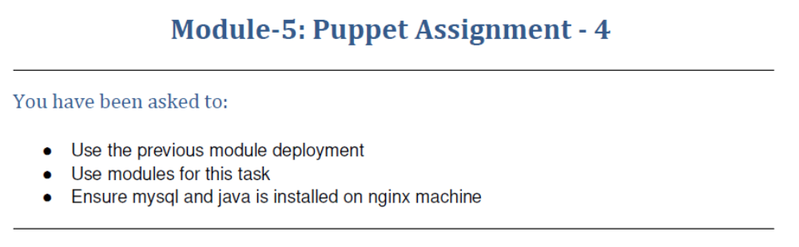
ubuntu@ip-172-31-33-191:~$ mkdir new
ubuntu@ip-172-31-33-191:~$ cd new
ubuntu@ip-172-31-33-191:~/new$ sudo puppet module generate Demo-new
Warning: `puppet module generate` is deprecated and will be removed in a future release. This action has been replaced by Puppet Development Kit. For more information visit https://puppet.com/docs/pdk/latest/pdk.html.
(location: /usr/lib/ruby/vendor_ruby/puppet/face/module/generate.rb:142:in `generate')
We need to create a metadata.json file for this module. Please answer the
following questions; if the question is not applicable to this module, feel free
to leave it blank.

Puppet uses Semantic Versioning (semver.org) to version modules.
What version is this module? [0.1.0]
--> 1.0.0

Who wrote this module? [Demo]
--> Veeranna G

What license does this module code fall under? [Apache-2.0]
-->

How would you describe this module in a single sentence?
--> Test module

Where is this module's source code repository?
--> Demo

Where can others go to learn more about this module?
--> Demo

Where can others go to file issues about this module?
--> Demo

----------------------------------------
{
"name": "Demo-new",
"version": "1.0.0",
"author": "Veeranna G",
"summary": "Test module",
"license": "Apache-2.0",
"source": "Demo",
"project_page": "Demo",
"issues_url": "Demo",
"dependencies": [
{
"name": "puppetlabs-stdlib",
"version_requirement": ">= 1.0.0"
}
],
"data_provider": null
}
----------------------------------------

About to generate this metadata; continue? [n/Y]
--> y

Notice: Generating module at /home/ubuntu/new/new...
Notice: Populating templates...
Finished; module generated in new.
new/spec
new/spec/spec_helper.rb
new/spec/classes
new/spec/classes/init_spec.rb
new/examples
new/examples/init.pp
new/manifests
new/manifests/init.pp
new/metadata.json
new/Rakefile
new/Gemfile
new/README.md
ubuntu@ip-172-31-33-191:~/new$ ls
new
ubuntu@ip-172-31-33-191:~/new$ cd new
ubuntu@ip-172-31-33-191:~/new/new$ ls
Gemfile README.md Rakefile examples manifests metadata.json spec
ubuntu@ip-172-31-33-191:~/new/new$ cd manifests/
ubuntu@ip-172-31-33-191:~/new/new/manifests$ ls
init.pp
ubuntu@ip-172-31-33-191:~/new/new/manifests$ sudo nano init.pp
ubuntu@ip-172-31-33-191:~/new/new/manifests$ cd ..
ubuntu@ip-172-31-33-191:~/new/new$ cd ..
ubuntu@ip-172-31-33-191:~/new$ sudo puppet module build new
Notice: Building /home/ubuntu/new/new for release
Module built: /home/ubuntu/new/new/pkg/Demo-new-1.0.0.tar.gz

ubuntu@ip-172-31-33-191:~/new$ sudo puppet module install ./new/pkg/Demo-new-1.0.0.tar.gz
Notice: Preparing to install into /etc/puppet/code/environments/production/modules ...
Notice: Downloading from https://forgeapi.puppet.com ...
Notice: Installing -- do not interrupt ...
/etc/puppet/code/environments/production/modules
└─┬ Demo-new (v1.0.0)
└── puppetlabs-stdlib (v8.1.0)

On Agent

ubuntu@ip-172-31-45-49:~$ sudo puppet agent --test
Info: Using configured environment 'production'
Info: Retrieving pluginfacts
Info: Retrieving plugin
Info: Retrieving locales
Info: Loading facts
Info: Caching catalog for ip-172-31-45-49.us-east-2.compute.internal
Info: Applying configuration version '1638926995'
Notice: /Stage[main]/Main/Node[default]/Package[nginx]/ensure: created
Notice: /Stage[main]/Main/Node[default]/File[/tmp/status.txt]/ensure: defined content as '{md5}33953125d5378c23cb0a98b5e2efe1d0'
Notice: Applied catalog in 5.59 seconds
ubuntu@ip-172-31-45-49:~$ ls
puppet-release-bionic.deb
ubuntu@ip-172-31-45-49:~$ cd /tmp
ubuntu@ip-172-31-45-49:/tmp$ ls
status.txt
systemd-private-a1bd90b62f9f4c058b727197ad0ef8e4-systemd-resolved.service-H3cZjb
systemd-private-a1bd90b62f9f4c058b727197ad0ef8e4-systemd-timesyncd.service-z6jU9b
ubuntu@ip-172-31-45-49:/tmp$ cat status.txt
nginx installedubuntu@ip-172-31-45-49:/tmp$

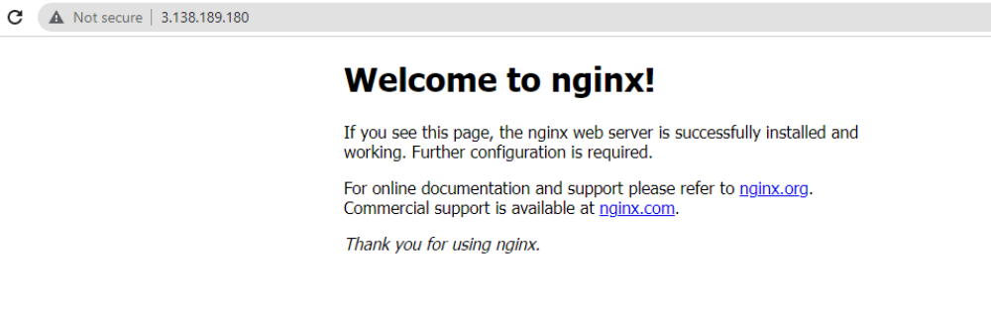
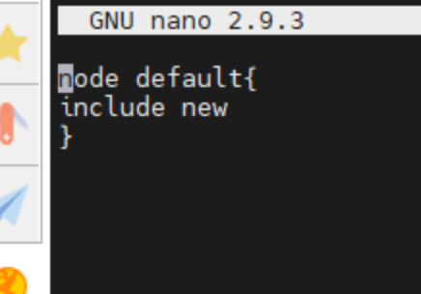
Module created to install java and my-sql
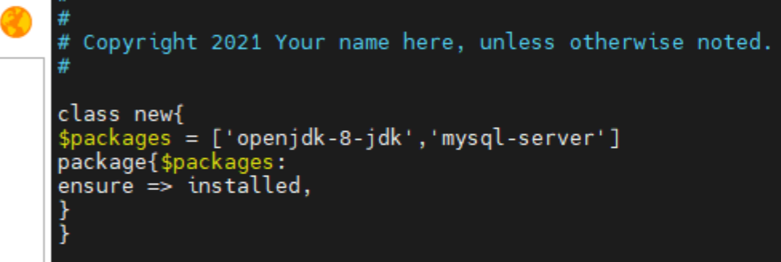
ubuntu@ip-172-31-45-49:~$ cd /etc
ubuntu@ip-172-31-45-49:/etc$ sudo nano hosts
ubuntu@ip-172-31-45-49:/etc$ cd ..
ubuntu@ip-172-31-45-49:/$ sudo puppet agent --test
Info: Using configured environment 'production'
Info: Retrieving pluginfacts
Info: Retrieving plugin
Info: Retrieving locales
Info: Loading facts
Info: Caching catalog for ip-172-31-45-49.us-east-2.compute.internal
Info: Applying configuration version '1638948983'
Notice: /Stage[main]/New/Package[openjdk-8-jdk]/ensure: created
Notice: /Stage[main]/New/Package[mysql-server]/ensure: created
Notice: Applied catalog in 58.95 seconds
ubuntu@ip-172-31-45-49:/$ java --version
Unrecognized option: --version
Error: Could not create the Java Virtual Machine.
Error: A fatal exception has occurred. Program will exit.
ubuntu@ip-172-31-45-49:/$ java -version
openjdk version "1.8.0_292"
OpenJDK Runtime Environment (build 1.8.0_292-8u292-b10-0ubuntu1~18.04-b10)
OpenJDK 64-Bit Server VM (build 25.292-b10, mixed mode)
ubuntu@ip-172-31-45-49:/$ service mysql service
Usage: /etc/init.d/mysql start|stop|restart|reload|force-reload|status
ubuntu@ip-172-31-45-49:/$ service mysql status
● mysql.service - MySQL Community Server
Loaded: loaded (/lib/systemd/system/mysql.service; enabled; vendor preset: enabled)
Active: active (running) since Wed 2021-12-08 07:37:18 UTC; 56s ago
Main PID: 18210 (mysqld)
Tasks: 27 (limit: 1140)
CGroup: /system.slice/mysql.service
└─18210 /usr/sbin/mysqld --daemonize --pid-file=/run/mysqld/mysqld.pid

Dec 08 07:37:18 ip-172-31-45-49 systemd[1]: Starting MySQL Community Server...
Dec 08 07:37:18 ip-172-31-45-49 systemd[1]: Started MySQL Community Server.
ubuntu@ip-172-31-45-49:/$

